QUESTION 5 – SYNCHRONIZATION: CRITICAL SECTIONS, SEMAPHORES AND MONITORS

1. Introduction
Process synchronization is an important concept in operating systems. It ensures that multiple processes or threads can access shared resources without creating conflicts.
In a railway ticket booking system, thousands of passengers may try to book seats at the same time.
Without proper synchronization, the same seat may be allocated to multiple passengers.
Therefore, synchronization mechanisms are required to maintain data consistency and prevent race conditions.

2. Problem Description
Consider a railway ticket booking system where multiple producers and consumers access a shared buffer.
Producers represent ticket booking requests, while consumers represent ticket processing operations.
The system must ensure that:
- No two threads access a critical section simultaneously.
- Producers cannot insert data into a full buffer.
- Consumers cannot remove data from an empty buffer.
- Every produced item is consumed exactly once.

3. Critical Section
A critical section is a part of a program where shared resources are accessed or modified.
For example, updating the available seat count is a critical section in a railway booking system.
The following requirements must be satisfied:
Mutual Exclusion: Only one process or thread can execute the critical section at a time.
Progress: If no thread is executing the critical section, the selection of the next thread should not be delayed unnecessarily.
Bounded Waiting: Every waiting thread must get an opportunity to enter the critical section within a limited number of turns.

4. Peterson's Solution
Peterson's solution is a software-based synchronization technique designed for two processes.
It uses two variables:
- flag[2] – Indicates whether a process wants to enter the critical section.
- turn – Indicates which process gets priority.
Peterson's solution satisfies mutual exclusion, progress and bounded waiting under its assumptions.
However, it is not a practical general-purpose solution for modern multiprocessor systems without appropriate memory-ordering guarantees.

5. Semaphores and Mutex
Semaphore:
A semaphore is a synchronization variable used to control access to shared resources.
Two main operations are:
- wait() – Decreases the semaphore value or blocks the calling thread.
- signal() – Increases the semaphore value and may wake a waiting thread.

Mutex:
A mutex is a locking mechanism that allows only one thread to access a protected critical section at a time.
In the railway booking system, a mutex can protect the shared seat counter from simultaneous updates.

6. Producer–Consumer Problem
The producer–consumer problem is a classical synchronization problem.
A producer generates items and stores them in a bounded buffer. A consumer removes items from the buffer.
Three synchronization mechanisms are commonly used:
- empty – Counts the available buffer positions.
- full – Counts the occupied buffer positions.
- mutex – Protects the shared buffer during access.
These mechanisms prevent buffer overflow, buffer underflow and race conditions.

7. Monitor and Condition Variables
A monitor is a high-level synchronization construct that combines shared data and operations into one protected unit.
Only one thread can execute inside a monitor at a time.
Condition variables allow threads to wait until a particular condition becomes true.
For example, a consumer waits when the buffer is empty and resumes when a producer inserts an item.
Monitors make synchronization easier to understand and maintain.

8. Implementation and Execution
The experiment was implemented in C using POSIX threads, mutexes and semaphores.
The program was tested with producer and consumer threads.
The bounded buffer was used to store produced items until they were consumed.

Commands:
mkdir -p ~/OS_Assignment_2/Q5
cd ~/OS_Assignment_2/Q5

nano q5.c

gcc q5.c -o q5 -pthread

./q5 1
The program was also tested with multiple producers and consumers.

9. Output Analysis
The program successfully demonstrated producer–consumer synchronization.
The execution output showed producers generating items and consumers consuming them.
The final results were:
Parameter | Observed Result
Total Items Produced | 20
Total Items Consumed | 20
Expected Sum | 210
Actual Sum | 210
Missing Items | 0
Duplicate Items | 0
The final result confirmed that all produced items were consumed exactly once.
Screenshot Placement:
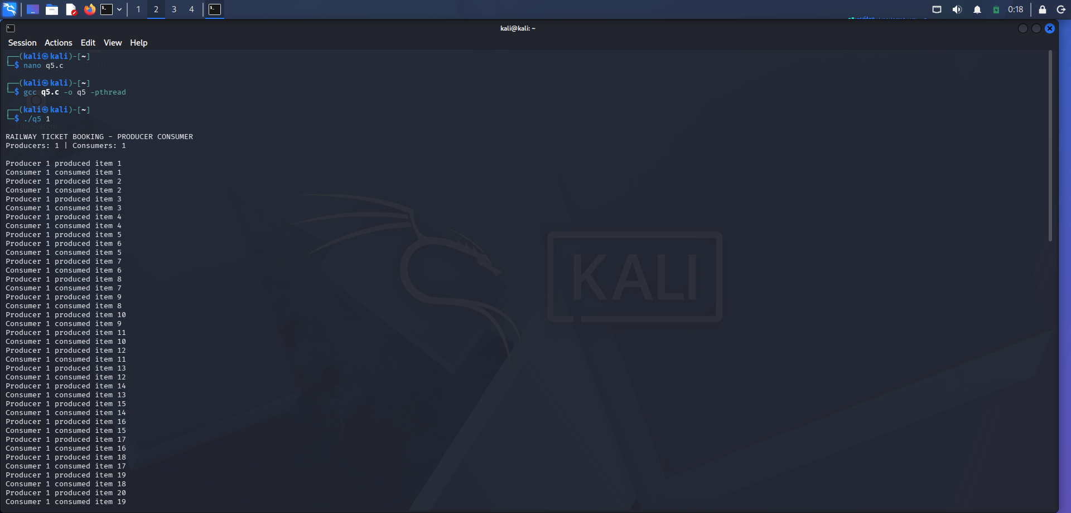
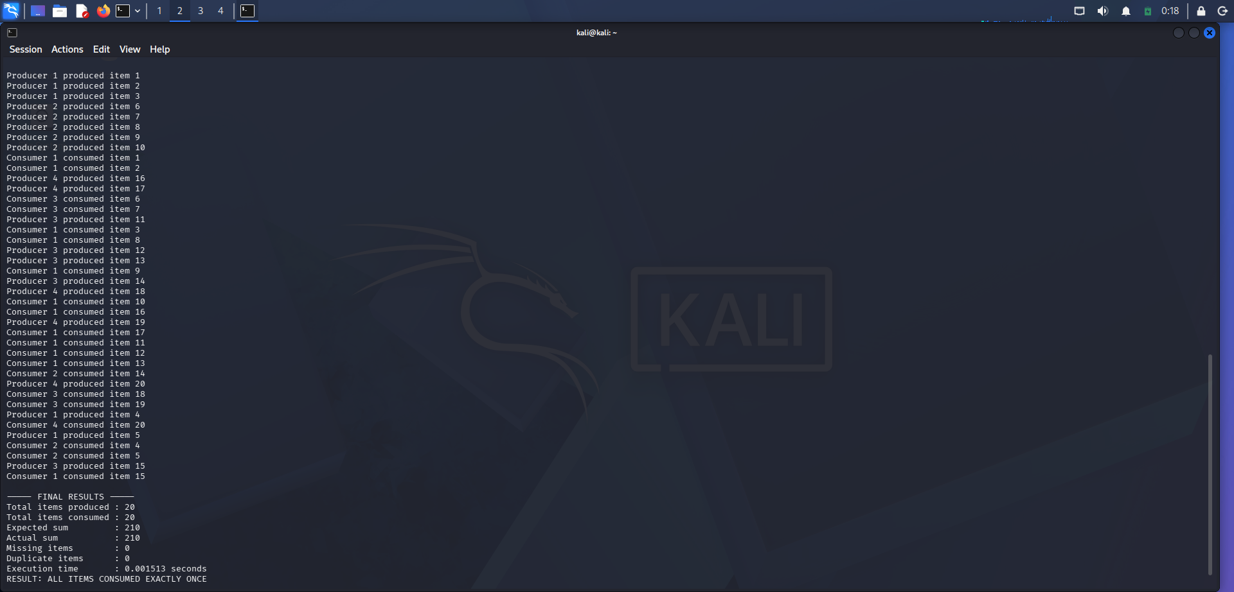

10. Alternative Concept and Complexity Analysis
If the shared buffer is protected only by atomic operations, individual updates may be atomic, but the complete producer–consumer operation may still require coordination.
A mutex and semaphores provide a suitable solution for this bounded-buffer problem.
For a system with one producer and four consumers, the synchronization mechanism must ensure that consumers do not access empty buffer positions.
For a large booking system, a lock per entire booking system is simple but can create contention.
Using separate locks for individual trains or coaches may improve throughput, provided that seat allocation and booking consistency are correctly maintained.

11. Conclusion
The experiment successfully demonstrated synchronization using POSIX threads, mutexes and semaphores.
The program produced 20 items and consumed all 20 items without missing or duplicate items. The expected and actual sums were both 210.
Therefore, synchronization mechanisms are essential for maintaining data consistency and preventing race conditions in railway ticket booking systems.

